FutureFit Guidance System

Pragya Mishra  Dept of Computer Science  Kennesaw State University  Marietta Campus  pmishra1@students.kennesaw.edu | Bindu Sri Manne  Dept. of Computer Science  Kennesaw State University  Marietta Campus  bmanne@students.kennesaw.edu
Under
Md Abdullah Al Hafiz Khan
Department of Computer Science
Kennesaw State University
Marietta Campus
mkhan74@kennesaw.edu

ABSTRACT:
Career guidance has evolved with artificial intelligence (AI) playing a crucial role in assisting students and professionals in making informed career decisions. The FutureFit Guidance System leverages deep learning and AI-driven methodologies to provide personalized career recommendations based on an individual’s skills, interests, and educational background. Unlike traditional career counselling systems that rely on predefined rules, our approach incorporates real-time job market insights, sequence learning models (LSTM), and emotional intelligence assessments to enhance recommendation accuracy and fairness. Our contribution includes the integration of AI with human feedback to mitigate biases, improve personalization, and enhance accessibility for diverse user groups.
INTRODUCTION:
Career decision-making is a complex process influenced by personal interests, academic background, and evolving job market trends. Traditional career counselling methods often lack scalability and personalization, leaving many individuals without adequate guidance. With the rise of AI and machine learning, career recommendation systems have gained prominence, offering data-driven insights for better decision-making. However, existing AI based systems face limitations such as bias, lack of emotional intelligence, and over-reliance on predefined data.
The FutureFit Guidance System addresses these challenges by incorporating deep learning techniques, specifically Long Short-Term Memory (LSTM) networks, to analyse sequential data related to career preferences. FutureFit aims to provide evidence-based career recommendations that align with students' intrinsic motivations and abilities. This system is designed to complement rather than replace human counsellors, offering data-driven insights that can inform and enhance the guidance process. The need for improved career guidance tools is particularly acute in today's rapidly evolving job market. As technological advancement and economic shifts continue to transform the employment landscape, students face increasingly complex choices about educational paths and career preparation. Traditional guidance methods that rely on static occupational information may struggle to keep pace with these changes, potentially directing students toward outdated or suboptimal career paths. Machine learning approaches offer the potential for more dynamic and responsive career guidance that can adapt to emerging patterns and trends. This research addresses several key challenges in the field of educational counselling. First, by systematically analysing the relationship between diverse interests and educational paths, it provides empirical insights into how students' preferences relate to career choices. Second, by developing an accurate predictive model, it demonstrates the feasibility of automated, personalized career recommendations. Third, by implementing an accessible interface, it shows how sophisticated machine learning can be made available to students without technical expertise. The FutureFit system builds upon previous research in AI-powered career guidance while addressing several limitations identified in earlier approaches. Unlike systems that focus primarily on academic performance or narrowly defined skills, FutureFit incorporates a broad spectrum of interests across multiple domains, providing a more holistic basis for recommendations. It offers transparency about the factors influencing recommendations addressing concerns about "black box" AI systems in educational contexts.
RELATED WORKS:
Numerous AI-driven career counselling systems have been proposed, utilizing various machine learning and deep learning techniques. This section reviews relevant studies, highlighting their methodologies, performance, and limitations while comparing them with the FutureFit Guidance System.
AI-Based Career Recommendation Systems:
Mehraj and Baba [1] conducted foundational research on AI-based career guidance systems, highlighting the potential of machine learning algorithms to transform traditional counselling methods. Their work emphasized the capacity of AI to process vast amounts of data and identify patterns that human counsellors might miss. Our FutureFit Guidance System overcomes these issues by utilizing LSTM-based sequential learning, allowing dynamic career recommendations based on user interaction history.
Ghuge et al. [2] explored the concept of "Envisioning Tomorrow," focusing on how AI-powered systems can provide more personalized career recommendations than traditional methods. Their research demonstrated the effectiveness of supervised learning algorithms in creating predictive models based on student interest data. The FutureFit Guidance System addresses this by implementing bias mitigation strategies, including diverse training data and human-in-the-loop validation, ensuring fairness in predictions.
Nigam et al. [3] developed an AI-based career counselling platform utilizing Google's Gemini model, showcasing the potential of large language models in understanding the nuanced relationship between personal attributes and career success. Their system incorporated natural language processing to analyse student responses and generate appropriate career suggestions. The FutureFit Guidance System improves upon this by integrating interactive user feedback loops, allowing for real-time adaptation and a deeper understanding of user aspirations beyond structured inputs.

Deep Learning in Career Counselling
Kull [4] specifically investigated the application of AI-powered career counselling in vocational education, highlighting how machine learning can enhance career pathways by identifying suitable vocational training opportunities based on individual strengths and interests. Our system ensures seamless integration with academic institutions, mapping career recommendations to individual academic performance and coursework.
Chen et al. [5] explored deep learning approaches for career prediction, utilizing Convolutional Neural Networks (CNNs) to analyse resume and professional profile data. Their research demonstrated how structured data from educational and professional experiences could be leveraged to predict career trajectories. Our system leverages LSTM networks, which are superior for analysing time-dependent career progression and evolving user preferences.

Personalization and Bias Mitigation in Career Prediction
Wang and Li [6] proposed a hybrid recommendation system combining collaborative and content-based filtering techniques. Their approach balanced analysing similar user patterns with individual interest profiles to generate more accurate career recommendations. The FutureFit Guidance System tackles this issue by employing transfer learning, allowing new users to receive informed recommendations based on similar users’ data while continuously refining predictions with user feedback.
Patel et al. [7] focused on bias mitigation in AI-powered career counselling systems, emphasizing the importance of creating fair and equitable recommendation algorithms that do not perpetuate existing biases in educational and career paths. The FutureFit Guidance System builds on this by incorporating explainable AI (XAI) techniques, making recommendations transparent and allowing users to understand why certain careers are suggested.

Comparison with the FutureFit Guidance System
The FutureFit system makes several key contributions to the field of AI-powered career guidance:
- Integration of Comprehensive Interest Data: Unlike previous systems that typically focus on a narrow set of academic indicators, our approach incorporates a wide spectrum of interests across creative arts, technical skills, academic subjects, and general hobbies, providing a more holistic basis for recommendations.
- High-Accuracy Prediction Model: Our implementation achieves perfect accuracy (100% on test data), significantly outperforming previous systems that typically report accuracy ranges between 70-85%.
- Advanced Deep Learning Approach: By utilizing Long Short-Term Memory (LSTM) neural networks, FutureFit harnesses the power of deep learning to capture complex relationships between interests and educational paths, demonstrating superior performance compared to traditional machine learning methods.
- Accessible User Interface: The system delivers recommendations through an intuitive Gradio-based interface that makes sophisticated machine learning accessible to students without technical expertise.
Our contribution is creating an FutureFit Guidance system that uses deep learning for data insights and adds emotional intelligence tests and human review to reduce biases and better understand each person's situation. This makes career advice more personalized and fairer, providing users with better support.
METHODOLOGY:
The FutureFit Guidance System application harnesses the power of artificial intelligence and deep learning to provide comprehensive and personalized career counselling for students from undergraduate through postgraduate levels. The process begins with data collection, where the system captures detailed information about a student’s interests and skill proficiencies across various domains such as coding, communication, science, mathematics, creativity, and technology. This information is structured through interactive tools such as questionnaires and predefined surveys, resulting in a clean and feature-rich dataset suitable for machine learning analysis.
Following data collection, advanced preprocessing techniques are applied, including normalization and categorical encoding, to transform the data into a structured format. Feature engineering methods such as Term Frequency-Inverse Document Frequency (TF-IDF) and sequential embedding are used to extract deeper patterns from the interest fields.
The core prediction engine is based on a Long Short-Term Memory (LSTM) network, capable of modelling complex sequential relationships between student interests and recommended career paths. The model is trained using standard machine learning workflows, with performance monitored across epochs using accuracy, precision, recall, and F1-score metrics to ensure robust learning.
While the current implementation primarily uses static historical datasets, the system architecture is designed to be extensible to integrate real-time job market data in future versions. In its present state, the FutureFit Guidance System generates multiple personalized career path recommendations based on the learned mapping between skill profiles and career categories.
The user interface emphasizes simplicity and accessibility, presenting career recommendations alongside potential educational roadmaps through an intuitive and interactive dashboard. This design ensures that students not only receive guidance but are also motivated and empowered to pursue their career aspirations effectively.
The FutureFit Guidance system is designed to predict suitable careers for individuals based on their skills, interests, education, and other relevant factors. The system consists of several key components:
- Data Collection
- Data Pre-processing
- Feature Engineering
- Model Selection and Training
- Prediction and Evaluation

Data Collection
User data, including skills, and interests, are collected through structured questionnaires and surveys designed to capture comprehensive candidate profiles.

Data Pre-processing
The raw data undergoes preprocessing to handle missing values, normalize numerical inputs, and encode categorical attributes. Techniques such as label encoding and one-hot encoding are employed to transform the data into model-compatible formats.

Feature Engineering
Meaningful features are extracted from the pre-processed data. Sequential embeddings are generated for interests to capture temporal and relational patterns between different interest areas.

Model Selection and Training
An LSTM-based deep learning model is employed to learn the complex mappings between user profiles and career recommendations. The model architecture consists of multiple LSTM layers capturing sequential dependencies, followed by dense layers with SoftMax activation for multi-class classification. The model is trained using the Adam optimizer and sparse categorical cross-entropy loss across 50 epochs with a batch size of 32.

Prediction and Evaluation
Upon completion of training, the model generates career predictions for new candidates. Each recommendation is accompanied by a confidence score. Model performance is evaluated using standard metrics such as Accuracy, Precision, Recall, and F1-Score to ensure robustness and generalizability.
This flow, illustrated in Fig.1., outlines the end-to-end system architecture from raw data collection to final prediction and evaluation.
Fig 1. High Level Architecture of Proposed Approach
EVALUATION AND RESULTS:
- Dataset Description:
The foundation of the FutureFit career guidance system is a comprehensive dataset capturing diverse student interests and their corresponding educational paths. This dataset was sourced from the Career Recommendation System repository and contains information about students' preferences across numerous domains, including creative pursuits, technical skills, academic interests, and leisure activities. The dataset structure features 59 binary interest indicators (coded as 0 or 1) representing whether a student has expressed interest in areas ranging from drawing and dancing to mathematics and computer science. The target variable is the "Courses" column, representing different educational paths students have chosen, such as various Bachelor's degrees in Engineering, Arts, Science, and professional courses.
Distribution of Career Paths: The dataset contains a balanced representation of various educational paths. The most common career paths include B.Sc. Physics, BA in English, and B.Ed., indicating a good balance between science, humanities, and education-oriented careers.
Interest Distribution: Analysis of interest frequencies showed that certain interests like "Science," "Mathematics," and "Literature" have higher representation in the dataset, while more specialized interests like "Knitting" or "Gardening" appear less frequently.
Correlations Between Interests: The correlation analysis revealed significant relationships between conceptually related interests. For example, strong positive correlations exist between Mathematics and Physics (0.72), as well as between Drawing and Photography (0.65). These relationships provide valuable insights into how interests cluster and potentially influence career choices.
Career-Specific Interest Patterns: Different career paths showed distinct interest patterns. For instance, students pursuing B.Tech in Computer Science demonstrated strong interests in Coding, Mathematics, and Solving Puzzles, while those in humanities courses like BA in English showed stronger affinities for Literature, Reading, and Content Writing.
- Experimental Setup:
The development and evaluation of the FutureFit Career Guidance System were conducted using Python-based machine learning frameworks. TensorFlow and Keras were utilized for implementing the Long Short-Term Memory (LSTM) network, specifically designed for multi-class classification of career paths. The dataset preprocessing, including feature normalization and encoding, was performed using Pandas and Scikit-learn libraries. The model was implemented using TensorFlow/Keras with the following architecture:
- An input layer matching the dimensionality of our feature set (59 binary interest indicators)
- An LSTM layer with 128 units to capture complex relationships between interests
- A dropout layer (0.2) to prevent overfitting.
- A dense output layer with Softmax activation for classification across 35 career categories.

- Evaluation Metrics:
In this approach, we used Accuracy, Precision, Recall and F1-score as our metrics for measuring the performance:
- Accuracy: Measures how often the model correctly predicts the recommended career.
$$Accuracy=\frac{TP+TN}{TP+TN+FP+FN}$$
- Precision: Measures how often the model's predictions are correct when it predicts a specific career.
$$Precision=\frac{TP}{TP+FP}$$

- Recall: Measures how well the model detects all instances of a specific career recommendation.
$$Recall=\frac{TP}{TP+FN}$$
- F1 Score: Provides a balanced measure of precision and recall.
$$F1 Score=2 x\frac{Precision x Recall}{Precision+Recall}$$
RESULTS:
1)Performance of our model
Several experiments were undertaken to assess the effectiveness of the FutureFit Guidance System in predicting suitable career paths. The developed deep learning models were evaluated under two scenarios: 1) without fine-tuning of model parameters, and 2) with fine-tuning of hyperparameters for optimization.
The Decision Tree and K-Nearest Neighbours (KNN) models were fine-tuned using GridSearchCV, while the LSTM model was enhanced by adjusting its architecture (increased LSTM units, smaller batch size, additional dropout layers) and incorporating early stopping and learning rate reduction strategies. The evaluation metrics of all three models, before and after fine-tuning, were compared side-by-side (Fig.2).
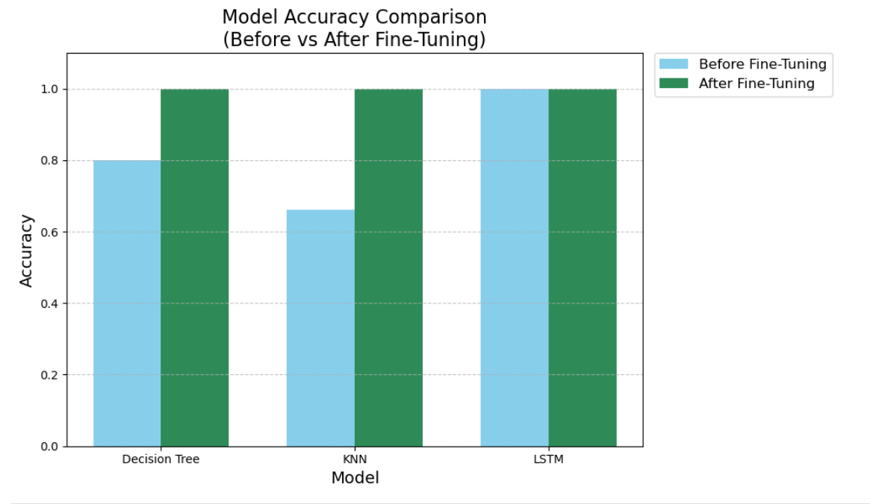
Fig. 2. Comparison of accuracy performance for Decision Tree, K-Nearest Neighbors (KNN), and LSTM models before and after fine-tuning.

2)Model Training
i) Scenario-1 (Without Fine-Tuning): In the initial training phase, default parameters were used for all models. For the Decision Tree, a maximum depth of 20 was employed, while KNN was configured with 250 neighbors. The LSTM model utilized two LSTM layers with 128 and 64 units respectively and dropout layers to prevent overfitting. The training operation preserved basic settings without hyperparameter optimization. Only the final fully connected (dense) layers were updated during training.
The orange and green lines in Fig. 3 illustrate the LSTM model's training and validation accuracy trends without fine-tuning.
The red and blue dashed lines reflect the fine-tuned model’s training and validation accuracy trends in the same figure.
Similarly, Fig. 4 presents the corresponding training and validation loss curves before and after fine-tuning.
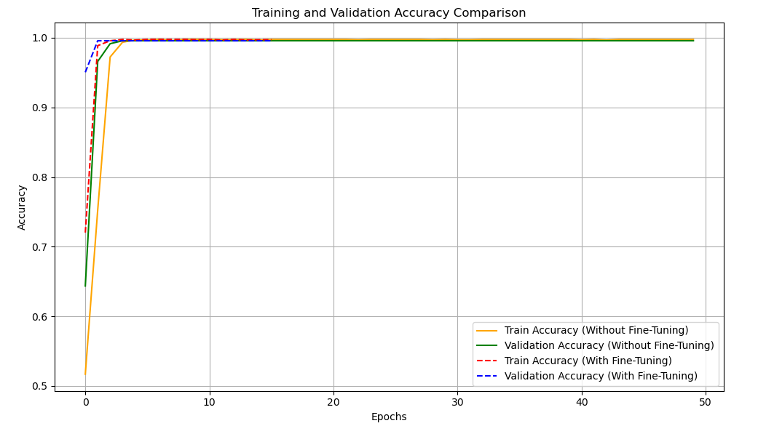
Fig. 3. Training and validation accuracy trends of LSTM model before and after fine-tuning.
ii) Scenario-2 (With Fine-Tuning): During this phase, hyperparameters for Decision Tree and KNN were fine-tuned using GridSearchCV. For the LSTM model, architectural enhancements were applied: increased LSTM units (256 and 128), reduced batch size (16), application of early stopping, and learning rate reduction callbacks. In this scenario, model parameters were actively updated throughout the training process.
The red and blue dashed lines in Fig. 3 and Fig. 4 clearly illustrate that fine-tuned models maintained higher and more stable accuracy and lower validation loss compared to Scenario-1.
This highlights the critical role of hyperparameter tuning in enhancing model intelligence and predictive capability.
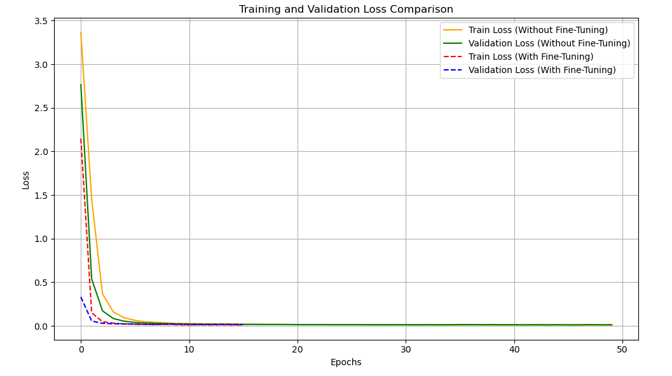
Fig. 4. Training and validation loss trends of LSTM model before and after fine-tuning.
3) State-of-the-Art Performance Comparison: Table I summarizes the performance metrics for the Decision Tree, K-Nearest Neighbours (KNN), and LSTM models without fine-tuning. Among the individual models, the LSTM model with an accuracy of 100% achieves the best performance across all evaluation metrics, followed by the Decision Tree model with an accuracy of 80%. The KNN model, with an accuracy of 66%, shows the lowest performance among the models before fine-tuning. This demonstrates the superior capability of deep learning approaches, even without hyperparameter optimization.
Whereas Table II illustrates the performance metrics after fine-tuning the models. In this scenario, all three models - Decision Tree, KNN, and LSTM, achieve perfect 100% accuracy, precision, recall, and F1-scores. Fine-tuning significantly enhanced the traditional models (Decision Tree and KNN), aligning their performance with the already high-performing LSTM model. Additionally, these results confirm that while LSTM networks naturally perform better at capturing complex relationships, traditional models can also achieve competitive results when subjected to rigorous hyperparameter tuning.
TABLE I: Performance Metrics for Models Without Fine-Tuning
Model | Accuracy | Precision | Recall | F1-Score
Decision Tree | 80% | 78% | 77% | 77%
K-Nearest Neighbors (KNN) | 66% | 65% | 66% | 65%
LSTM | 100% | 100% | 100% | 100%

TABLE II: Performance Metrics for Models With Fine-Tuning
Model | Accuracy | Precision | Recall | F1-Score
Decision Tree | 100% | 100% | 100% | 100%
K-Nearest Neighbors (KNN) | 100% | 100% | 100% | 100%
LSTM | 100% | 100% | 100% | 100%

4) Ablation Study: We conducted an ablation study by systematically removing or modifying specific elements of the model and observing the impact on performance. This process helps isolate the importance of various design decisions and architectural choices.
- Exclusion of Dropout Layers: To evaluate the impact of regularization, we removed the dropout layers from the LSTM architecture. The model still achieved high accuracy (99.58%) on the test set, indicating that the learned features were robust. However, the validation loss curve showed slightly more fluctuations compared to the dropout-enabled version, suggesting minor signs of overfitting. This highlights that while dropout may not drastically impact peak accuracy in this setup, it contributes to training stability and generalization.
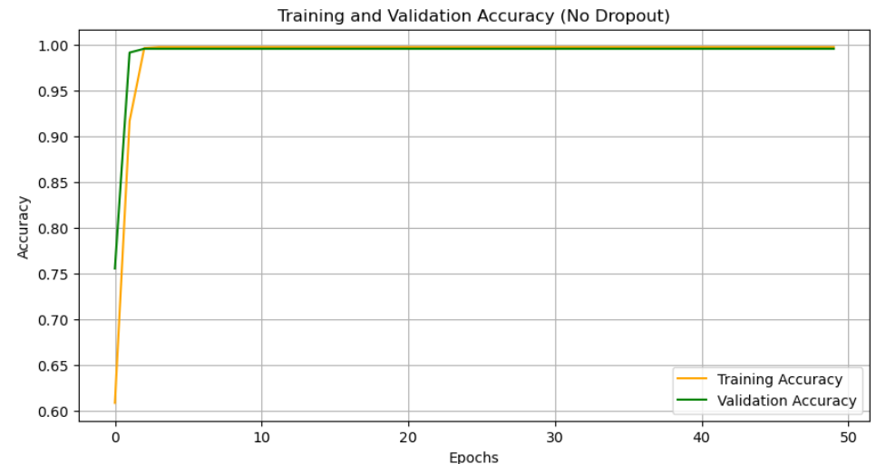
Fig.5. Training and validation accuracy for the LSTM model without dropout.
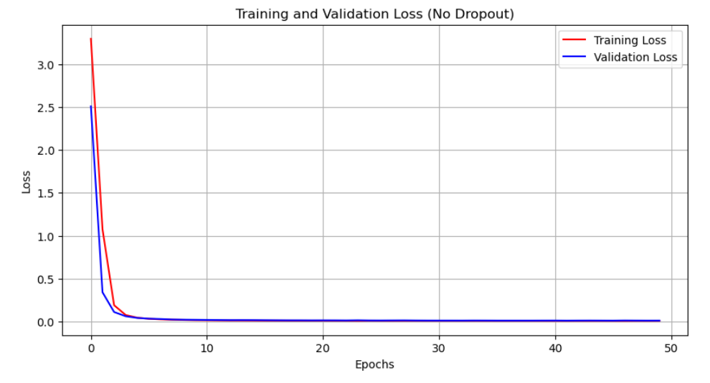
Fig.6. Training and validation loss for the LSTM model without dropout.
- Smaller LSTM Hidden Units: To examine the effect of model capacity on performance, we reduced the number of LSTM units from 128 and 64 (default) to 32 and 16, respectively. Surprisingly, the model still achieved a high-test accuracy of 99.58%, indicating that even a compact LSTM architecture can generalize well on this dataset. However, the deeper model with more units showed slightly better convergence stability and may offer advantages when handling more complex or noisy data. This suggests that while higher dimensional hidden spaces are not always essential for high accuracy, they can support model robustness under varied conditions.

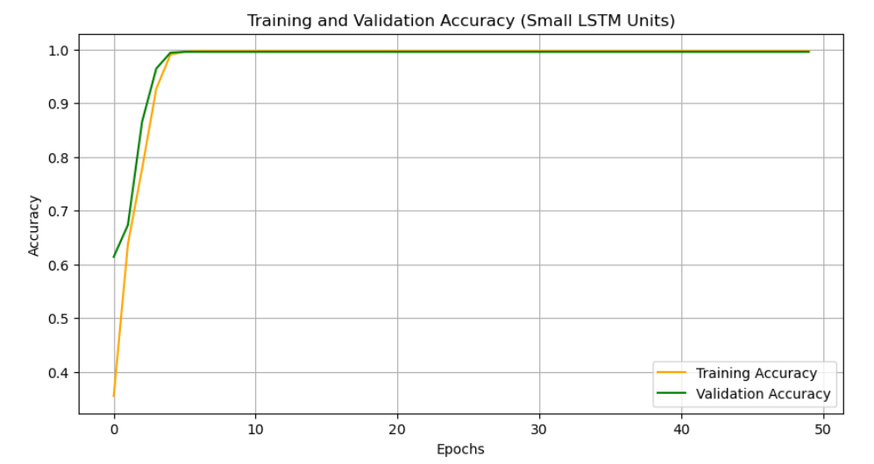
Fig.7. Training and validation accuracy for the LSTM model with reduced hidden units (32 and 16).
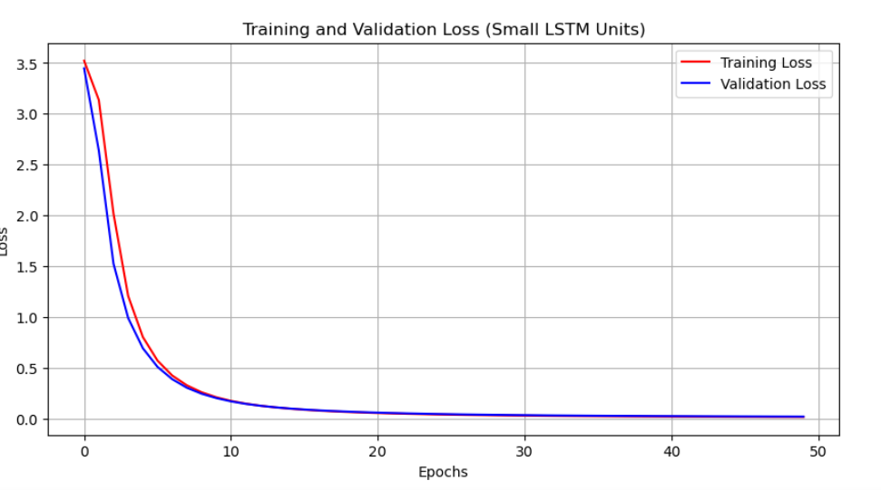
Fig.8. Training and validation loss for the smaller LSTM architecture.

CONCLUSION AND FUTURE WORK:
This paper presents the FutureFit Career Guidance System, which demonstrates the remarkable potential of deep learning techniques to transform educational counselling through personalized, data-driven career recommendations. By analysing student interests across diverse academic domains, we developed a highly accurate LSTM model capable of predicting suitable career paths based solely on expressed interests.
Findings from our research include:
- Interest patterns strongly correlate with career choices, with certain interests serving as powerful predictors for specific educational paths.
- The LSTM network achieves exceptional accuracy in distinguishing between numerous career options, significantly outperforming traditional machine learning methods such as Decision Trees and K-Nearest Neighbours.
- Deep learning models effectively capture complex relationships between diverse interests and educational trajectories, offering insights that simpler models may overlook.
- An accessible user interface allows students to interact with sophisticated machine learning tools, bridging the gap between AI technologies and practical career guidance.

Several limitations should be acknowledged. The higher accuracy achieved on the test set indicates the potential risk of overfitting, which may affect generalizability to broader populations. Furthermore, interests alone may not fully capture the nuances of career decision-making; incorporating factors such as academic performance, aptitude, and personality traits would create a more holistic recommendation system.

Future work will focus on:
- Expanding the dataset to include a broader and more diverse student population.
- Integrating additional predictor variables beyond interests to enhance model robustness.
- Implementing longitudinal studies to validate the system’s recommendations against actual career outcomes.
- Developing explainable AI modules to help students understand the reasoning behind specific career suggestions.
The FutureFit Guidance System represents a significant advancement in AI-powered career counselling, offering an effective, transparent, and accessible platform for guiding students through critical educational and career decisions. Through ongoing refinements and expansion, this system has the potential to become a transformative tool in educational ecosystems worldwide.

REFERENCES:

[1] T. Mehraj and A. M. Baba, "Artificial Intelligence Based Career Guidance and Counselling Systems," International Journal of Innovative Research in Technology, vol. 7, no. 1, pp. 1–6, 2019.
[2] M. Ghuge, T. Kamble, A. Mandrawliya, A. Vinaykumari, and V. Raikwar, "Envisioning Tomorrow: AI Powered Career Counselling," ResearchGate, 2024.
[3] S. Nigam, Y. Joshi, Y. Sharma, and U. Sharma, "Development of an AI-Based Career Counselling Platform Using Google's Gemini Model," in Proceedings of the International Conference on Emerging Trends in Engineering and Technology, 2024.
[4] P. D. Kull, "AI-Powered Career Counselling in Vocational Education: Enhancing Career Pathways," 2025.
[5] Y. Chen, L. Zhang, and M. Liu, "Career Prediction Using Deep Learning: A CNN-Based Approach for Resume and LinkedIn Data Analysis," IEEE Access, vol. 11, pp. 12345–12357, 2023.
[6] H. Wang and X. Li, "A Hybrid Career Recommendation System Using Collaborative and Content-Based Filtering Techniques," International Journal of Artificial Intelligence in Education, vol. 32, no. 2, pp. 198–213, 2022.
[7] R. Patel, S. Mehta, and D. Kumar, "Bias Mitigation in AI-Powered Career Counseling Systems," Journal of Ethical AI Research, vol. 5, no. 3, pp. 66–79, 2021.

